

AMERICAN INTERNATIONAL UNIVERSITY- BANGLADESH (AIUB)
Introduction to Electrical Circuit
FALL 2023-2024
Section: L, Group: 07

LAB REPORT ON

Verification of Kirchoff’s Voltage Law (KVL) and Kirchoff’s Current Law (KCL)

Supervised By

MD. SHAHARIAR PARVEZ

Name | ID
1.MD. Abdullah | 22-48065-2
2.Azmir Islam Kafi | 22-47981-2
3.Mohammad Ansar Uddin | 22-47975-2
4.Chinmoy Guha | 22-48056-2
5.Suvra Chakraborty | 22-48067-2

Abstract:
Kirchhoff's circuit laws, introduced by Gustav Kirchhoff in 1845, are two fundamental principles that pertain to current and voltage (potential difference) within electrical circuits. These laws are often referred to as Kirchhoff's rules or Kirchhoff's laws. They provided a generalized framework building upon the earlier work of Georg Ohm and predated Maxwell's contributions. Widely applied in the field of electrical engineering, the objectives of this experiment are as follows:
- To gain practical insight into Kirchhoff's Voltage Law (KVL) and Kirchhoff's Current Law (KCL).
- To validate experimentally obtained values against calculated values.

Apparatus:
- Resistors
- Connecting wire
- Trainer Board
- AVO meter or Multimeter
- DC source

Circuit Diagram: 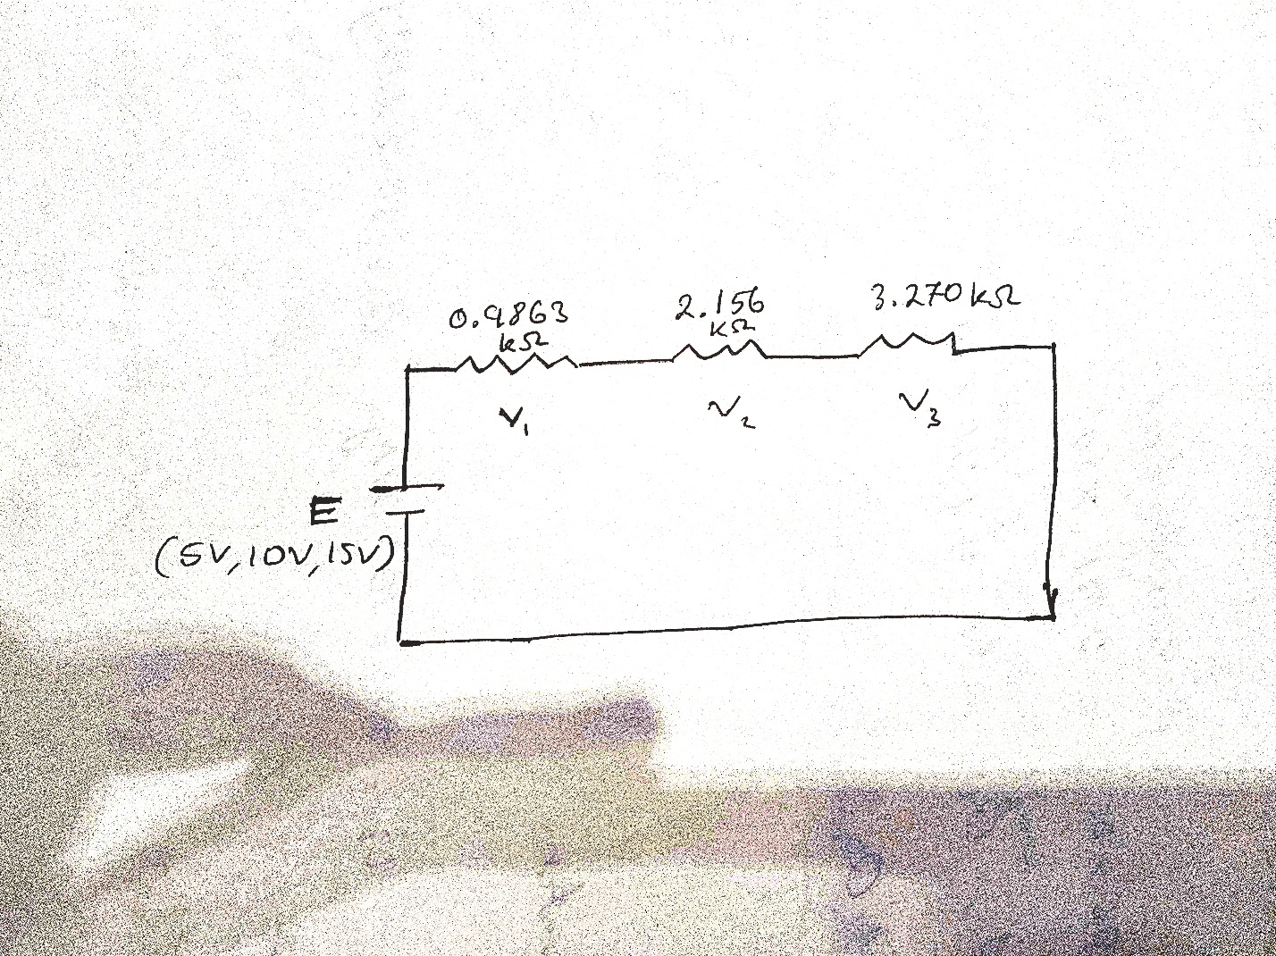
Diagram 1: Loop circuit

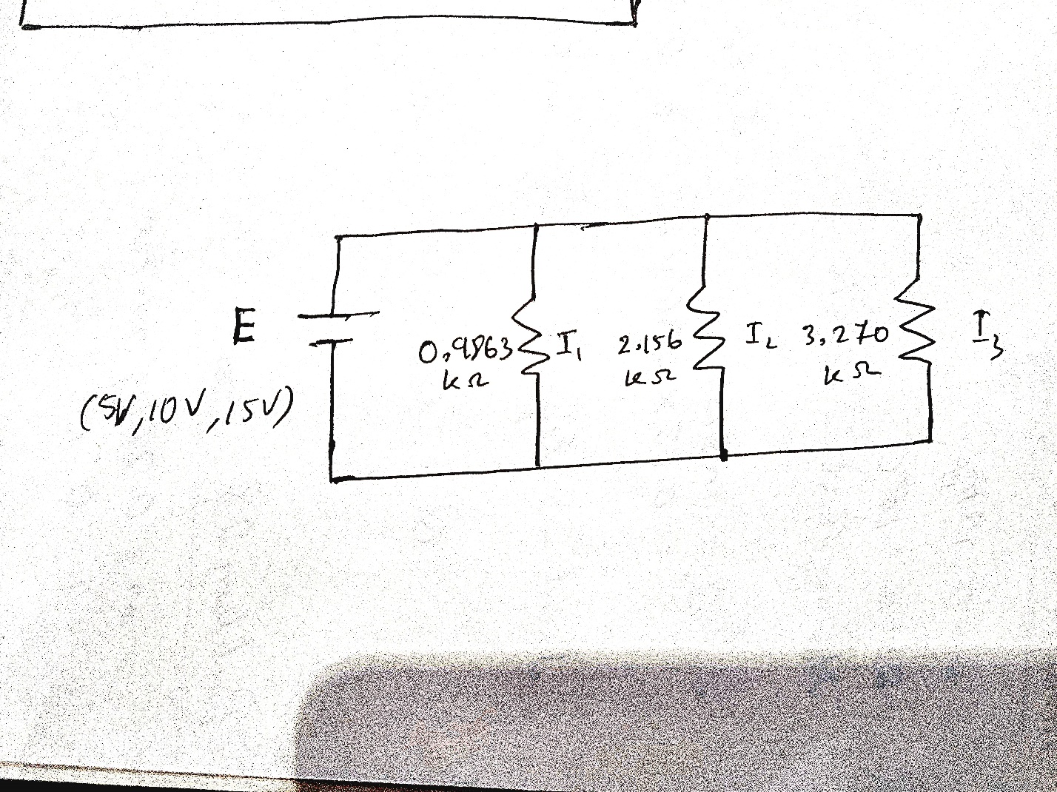
Diagram 2: Node circuit

Experimental Data & Procedure:
We connected the circuit in the breadboard as shown in the diagram 1, then the voltage across each element of the circuit was measured.
After that, we filled the following table with necessary calculations.

No  Of  Obs. | R₁  KΩ | R₂  KΩ | R₃  KΩ | Source  Voltage  (v) |  | Voltage across R1,  V₁ |  | Voltage across R2,  V₂ |  | Voltage across R3,  V3 |  | Total Voltage Drop =  V₁+V₂+V₃  _{(V)} |  | %Error  =%(mv  -cv) /CV
 |  |  |  | CV | MV | CV | MV | CV | MV | CV | MV | CV | MV
1 | 0.9863 | 2.156 | 3.270 | 5 | 5.052 | 0.769 | 0.7774 | 1.681 | 1.699 | 2.549 | 2.575 | 4.999 | 5.0517 | 1.05%
2 | 0.9863 | 2.156 | 3.270 | 10 | 10.085 | 1.538 | 1.5518 | 3.3622 | 3.390 | 5.099 | 5.140 | 9.999 | 10.081 | 0.82%
3 | 0.9863 | 2.156 | 3.270 | 15 | 15.090 | 2.307 | 2.321 | 5.043 | 5.073 | 7.649 | 7.690 | 14.99 | 15.084 | 0.62%

TABLE-1

Then we connected the circuit as shown in diagram 2. After that, the current across each branch or node of the circuit was measured. In the end, the following table was filled with necessary calculations.

TABLE-2
No  Of  Obs. | R₁  KΩ | R₂  KΩ | R₃  KΩ |  | I |  |  | I1 |  | I2 |  |  | I3 |  | I=I1+I2 +I3 |  | %Error =%(  mv-  cv) /CV
 |  |  |  | C  A |  | M  A | C  A |  | M  A | C  A | M  A | C  A |  | M  A | C  A | M  A
1 | 0.9863 | 2.156 | 3.270 | 8.913 |  | 8.850 | 5.069 |  | 5.071 | 2.319 | 2.333 | 1.529 |  | 1.540 | 8.917 | 8.944 | 0.3%
2 | 0.9863 | 2.156 | 3.270 | 17.83 |  | 17.42 | 10.14 |  | 10.22 | 4.638 | 4.613 | 3.058 |  | 3.043 | 17.836 | 17.876 | 0.22%
3 | 0.9863 | 2.156 | 3.270 | 26.74 |  | 26.25 | 15.21 |  | 15.72 | 6.957 | 6.937 | 4.587 |  | 4.573 | 26.752 | 27.23 | 1.79%

Theoretical Calculation:
For KVL:
Here, R₁=0.9863 KΩ
R₂= 2.156 KΩ
R₃=3.270 KΩ
For, V = 5 V
R_{T}=(0.9863+2.156+3.270)= 6.4123 KΩ
I = V/R_{T}= 0.7797 V
V₁ = IR₁= (0.7797×0.9863)=0.769 V
V₂ = IR₂= (0.7797×2.156)=1.68 V
V₃ = IR₃= (0.7797×3.270)=2.549 V

For, V = 10 V
R_{T}=(0.9863+2.156+3.270)= 6.4123 KΩ
I = V/R_{T}= 1.559 V
V₁ = IR₁= (1.559 ×0.9863)= 1.538V
V₂ = IR₂= (1.559 ×2.156)= 3.3622V
V₃ = IR₃= (1.559 ×3.270)= 5.099V

For, V = 15 V
R_{T}=(0.9863+2.156+3.270)= 6.4123 KΩ
I = V/R_{T}= 2.339 mA
V₁ = IR₁= (2.339 ×0.9863)=2.30 V
V₂ = IR₂= (2.339 ×2.156)=5.04 V
V₃ = IR₃= (2.339 ×3.270)=7.64 V
For KCL:
Here, R₁=0.9863 KΩ
R₂= 2.156 KΩ
R₃=3.270 KΩ
R_{T}=(0.9863⁻¹+2.156 ⁻¹+3.270 ⁻¹)⁻¹= 0.561 KΩ
For 1st observation V1=5V,
I₁=V/R₁=(5/0.9863) =5.06 mA
I₂=V/R₂=(5/2.156) =2.31 mA
I₃=V/R₃=(5/3.270) =1.52 mA
When V=10 V,
I₁=V/R₁=(10/0.9863) =10.13 mA
I₂=V/R₂=(10/2.156) =4.63 mA
I₃=V/R₃=(10/3.270) =3.05 mA
When V=15 V,
I₁=V/R₁=(15/0.9863) =15.20 mA
I₂=V/R₂=(15/2.156) =6.95 mA
I₃=V/R₃=(15/3.270) =4.58 mA

Simulation:

For KVL (table1):
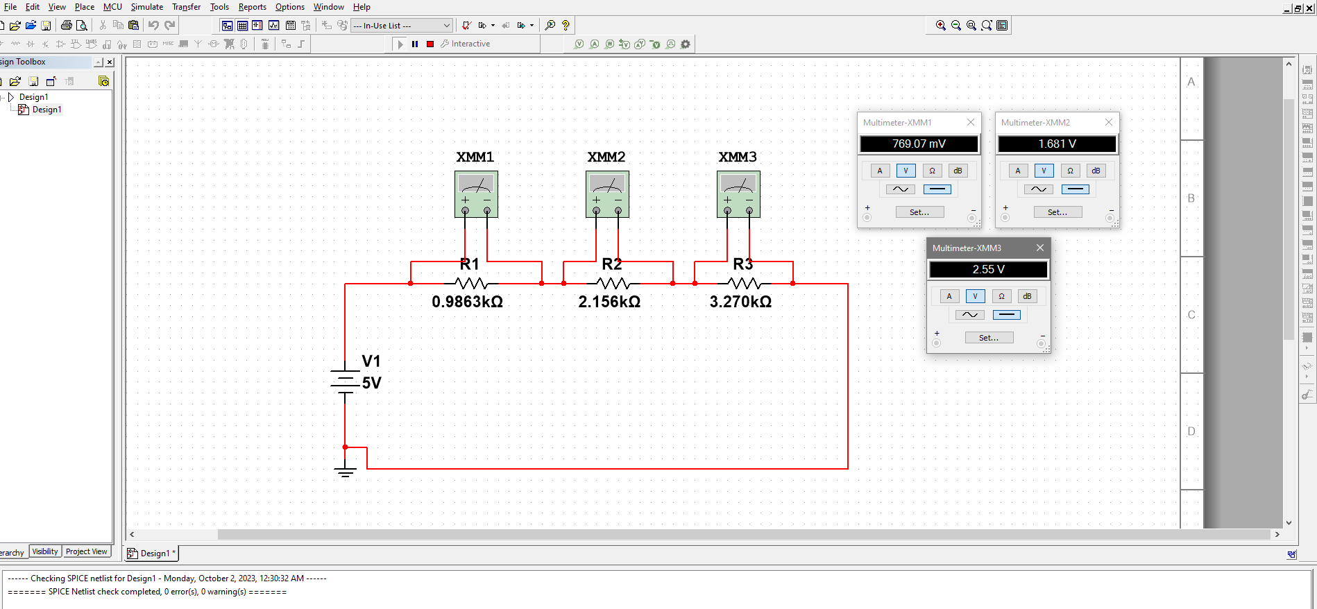
Figure: When the V=5V, the multimeter reading for V1, V2 and V3.

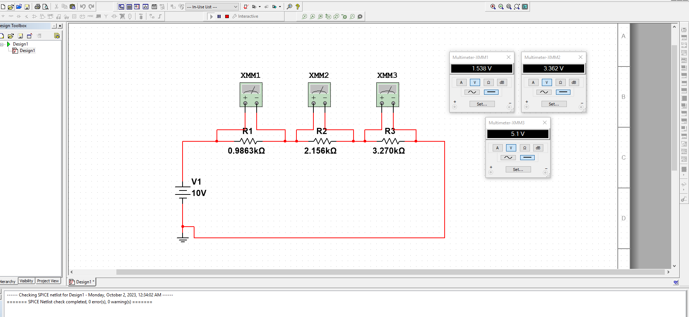

Figure: When the V=10V, the multimeter reading for V1, V2 and V3.

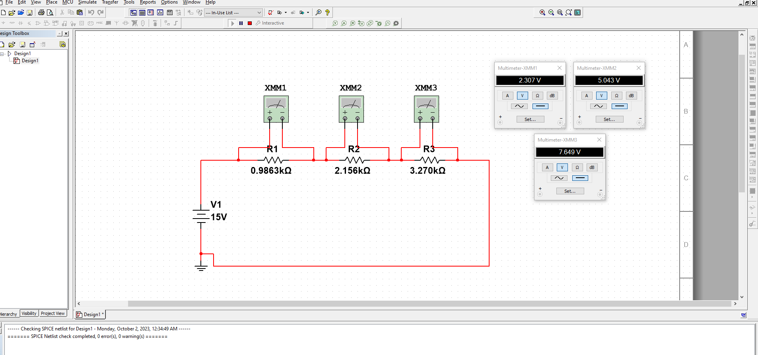
Figure: When the V=15V, the multimeter reading for V1, V2 and V3.

For KCL (table2):

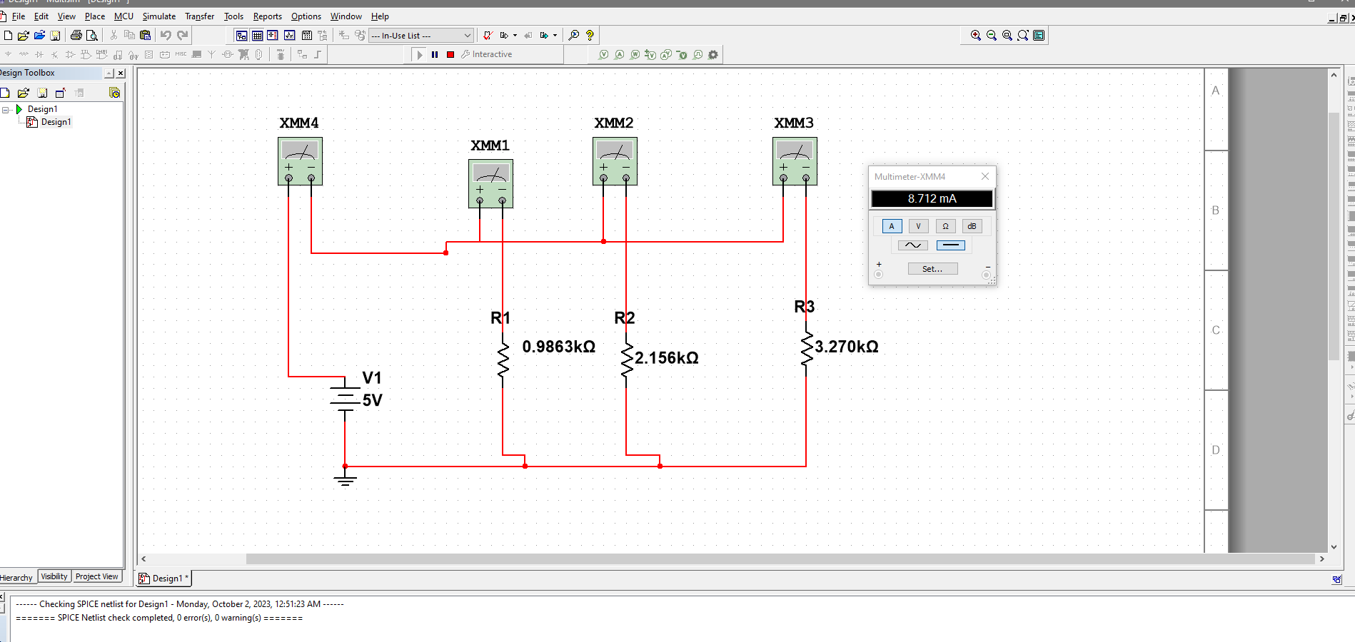
Figure: When the V=5V, the multimeter reading for Total Current I.

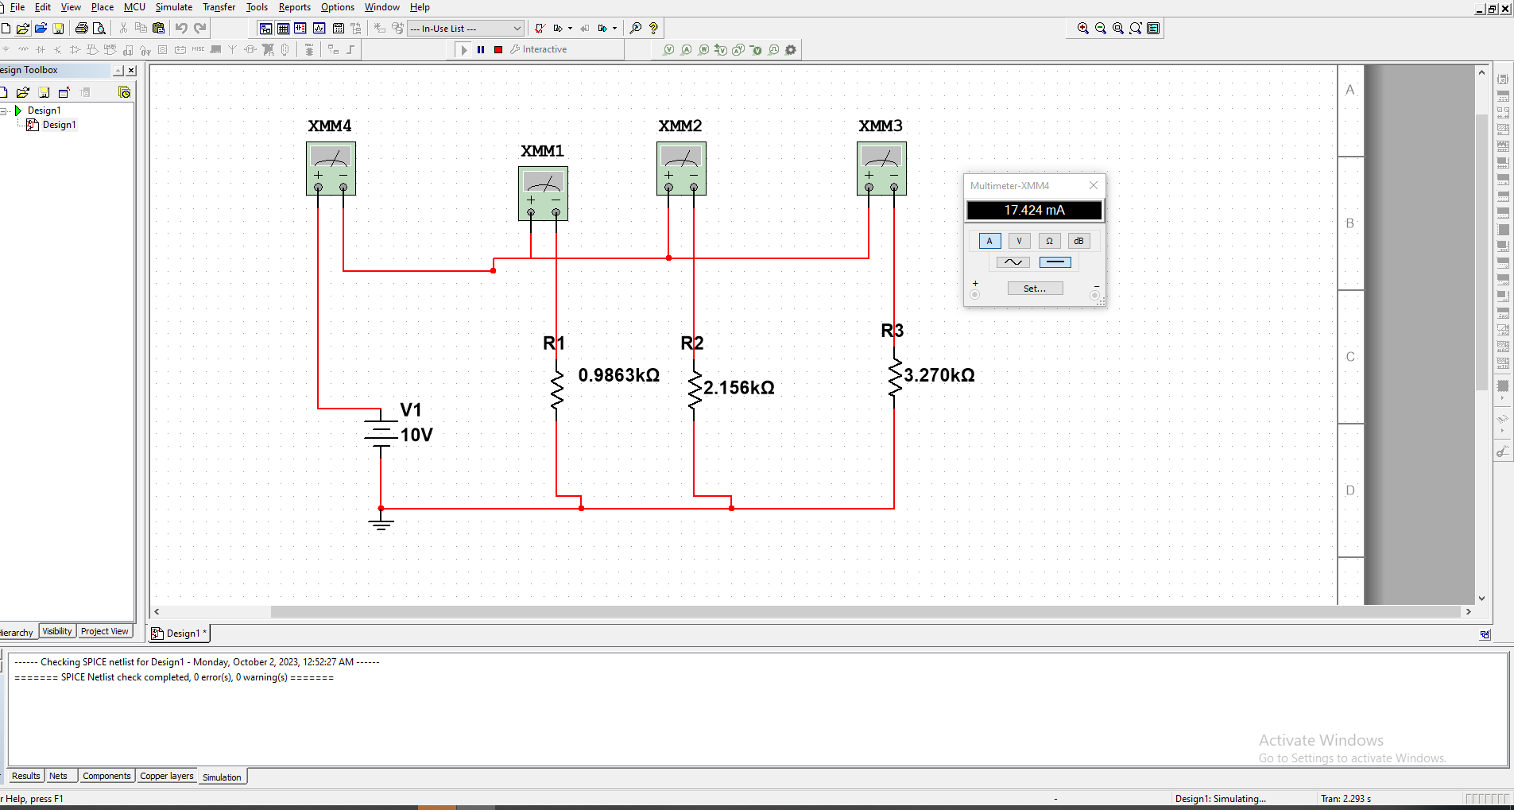
Figure: When the V=10V, the multimeter reading for Total Current I.

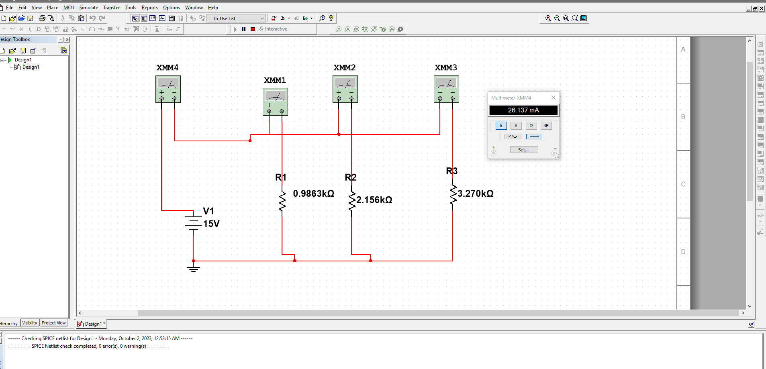
Figure: When the V=15V, the multimeter reading for Total Current I.

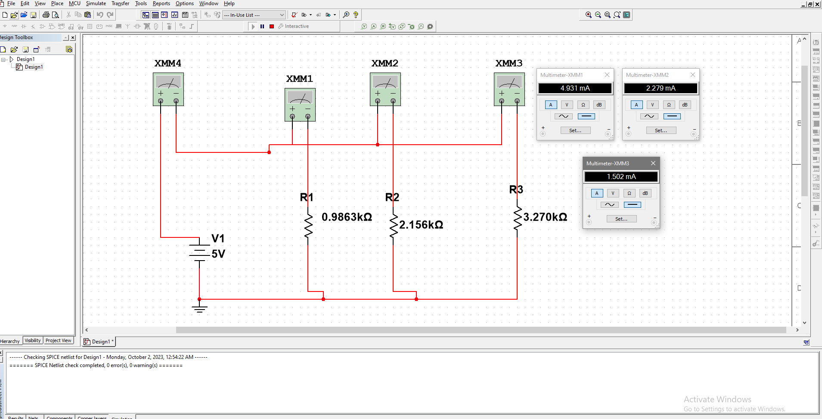

Figure: When the V=5V, the multimeter current reading for I1, I2 and I3.

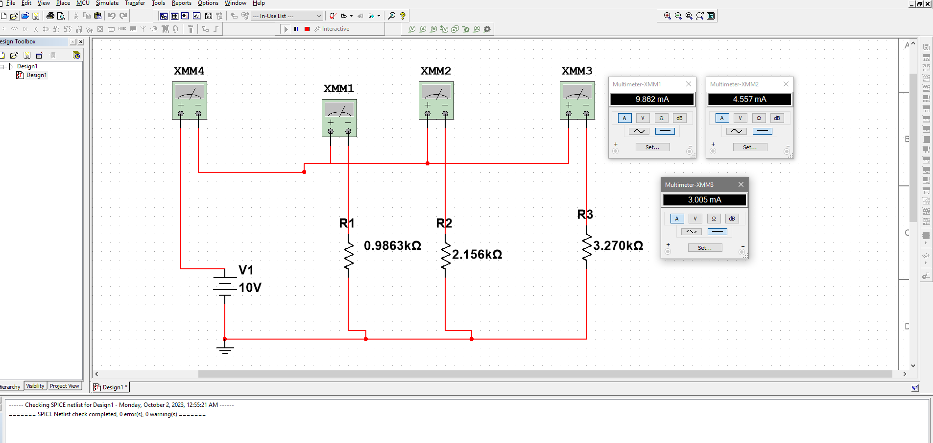

Figure: When the V=10V, the multimeter current reading for I1, I2 and I3.

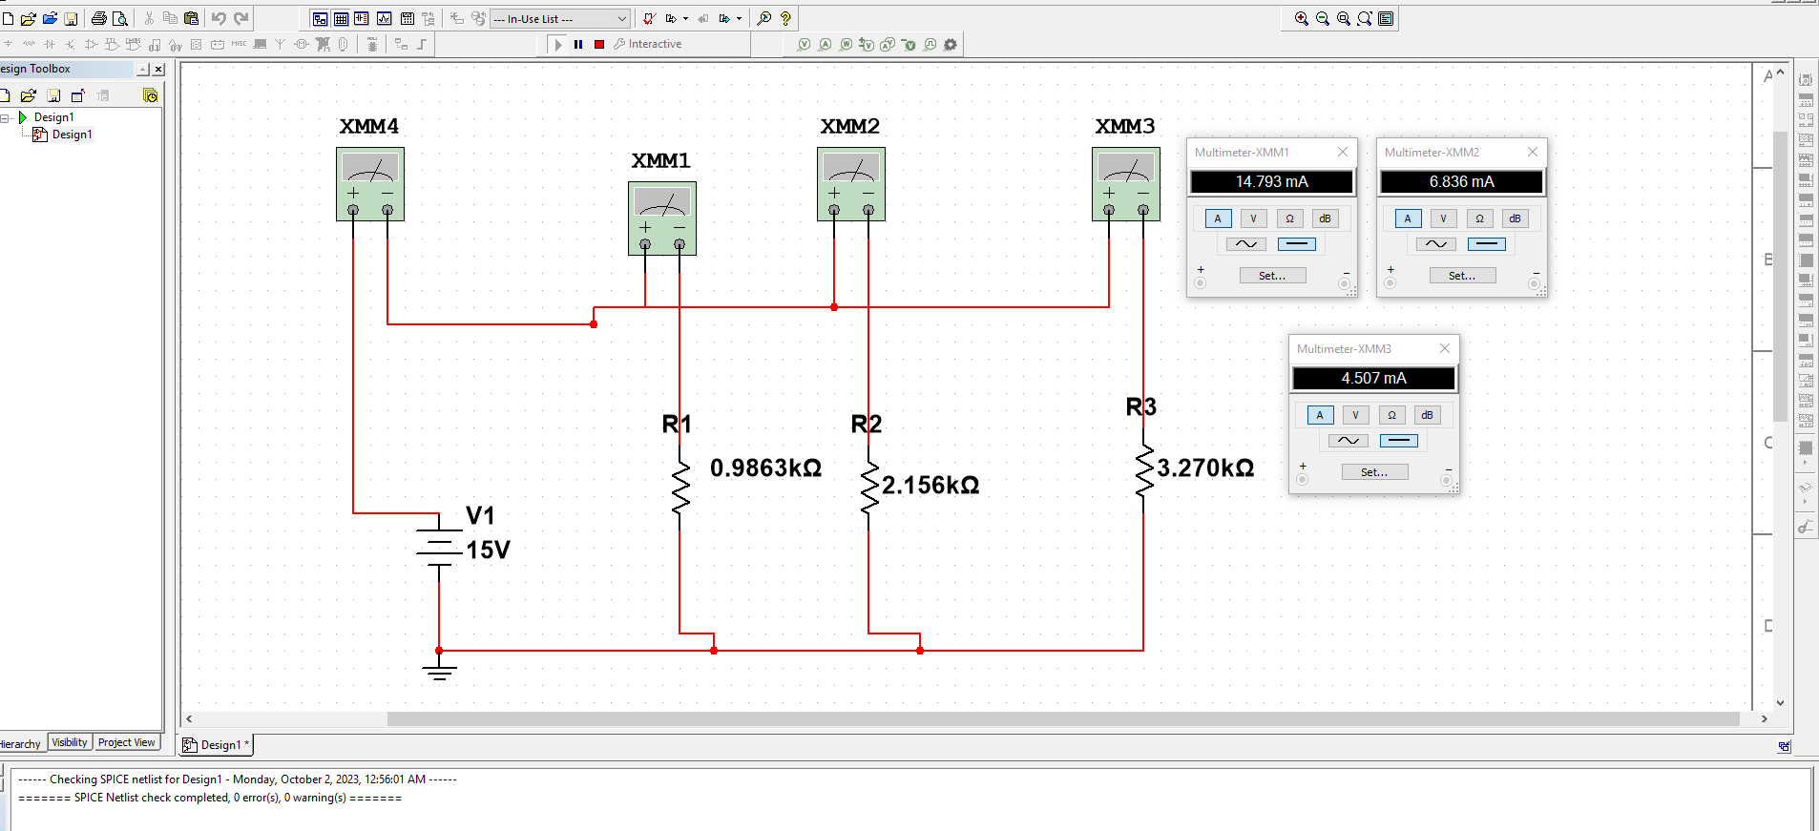
Figure: When the V=15V, the multimeter current reading for I1, I2 and I3.

Discussion:
In this experiment we created two circuits to verify KVL and KCL. In the 1st circuit we connected the circuit in a series connection and measured voltage using a multimeter across the resistors to satisfy KVL and in the 2nd circuit we connected it in a parallel connection and measured the current using a multimeter across the resistors to verify KCL. After we calculated our values for voltage in the series circuit, current in the parallel circuit respectively we found out, we do have some errors, it might be due to the human error while taking measurement, resistance in wires, temperature not being constant etc.
Conclusion:
Our results indicate that the calculated values and our measured values are quite similar to each other and the percentage error is less than 5% so we can say that it is in the accepted range and therefore our experiment was successful.

